Control Phase 2

Site: Elevation: Treatment Date:

Trees: Shrub: Perennial Grass: Total Grass: Bare Ground:

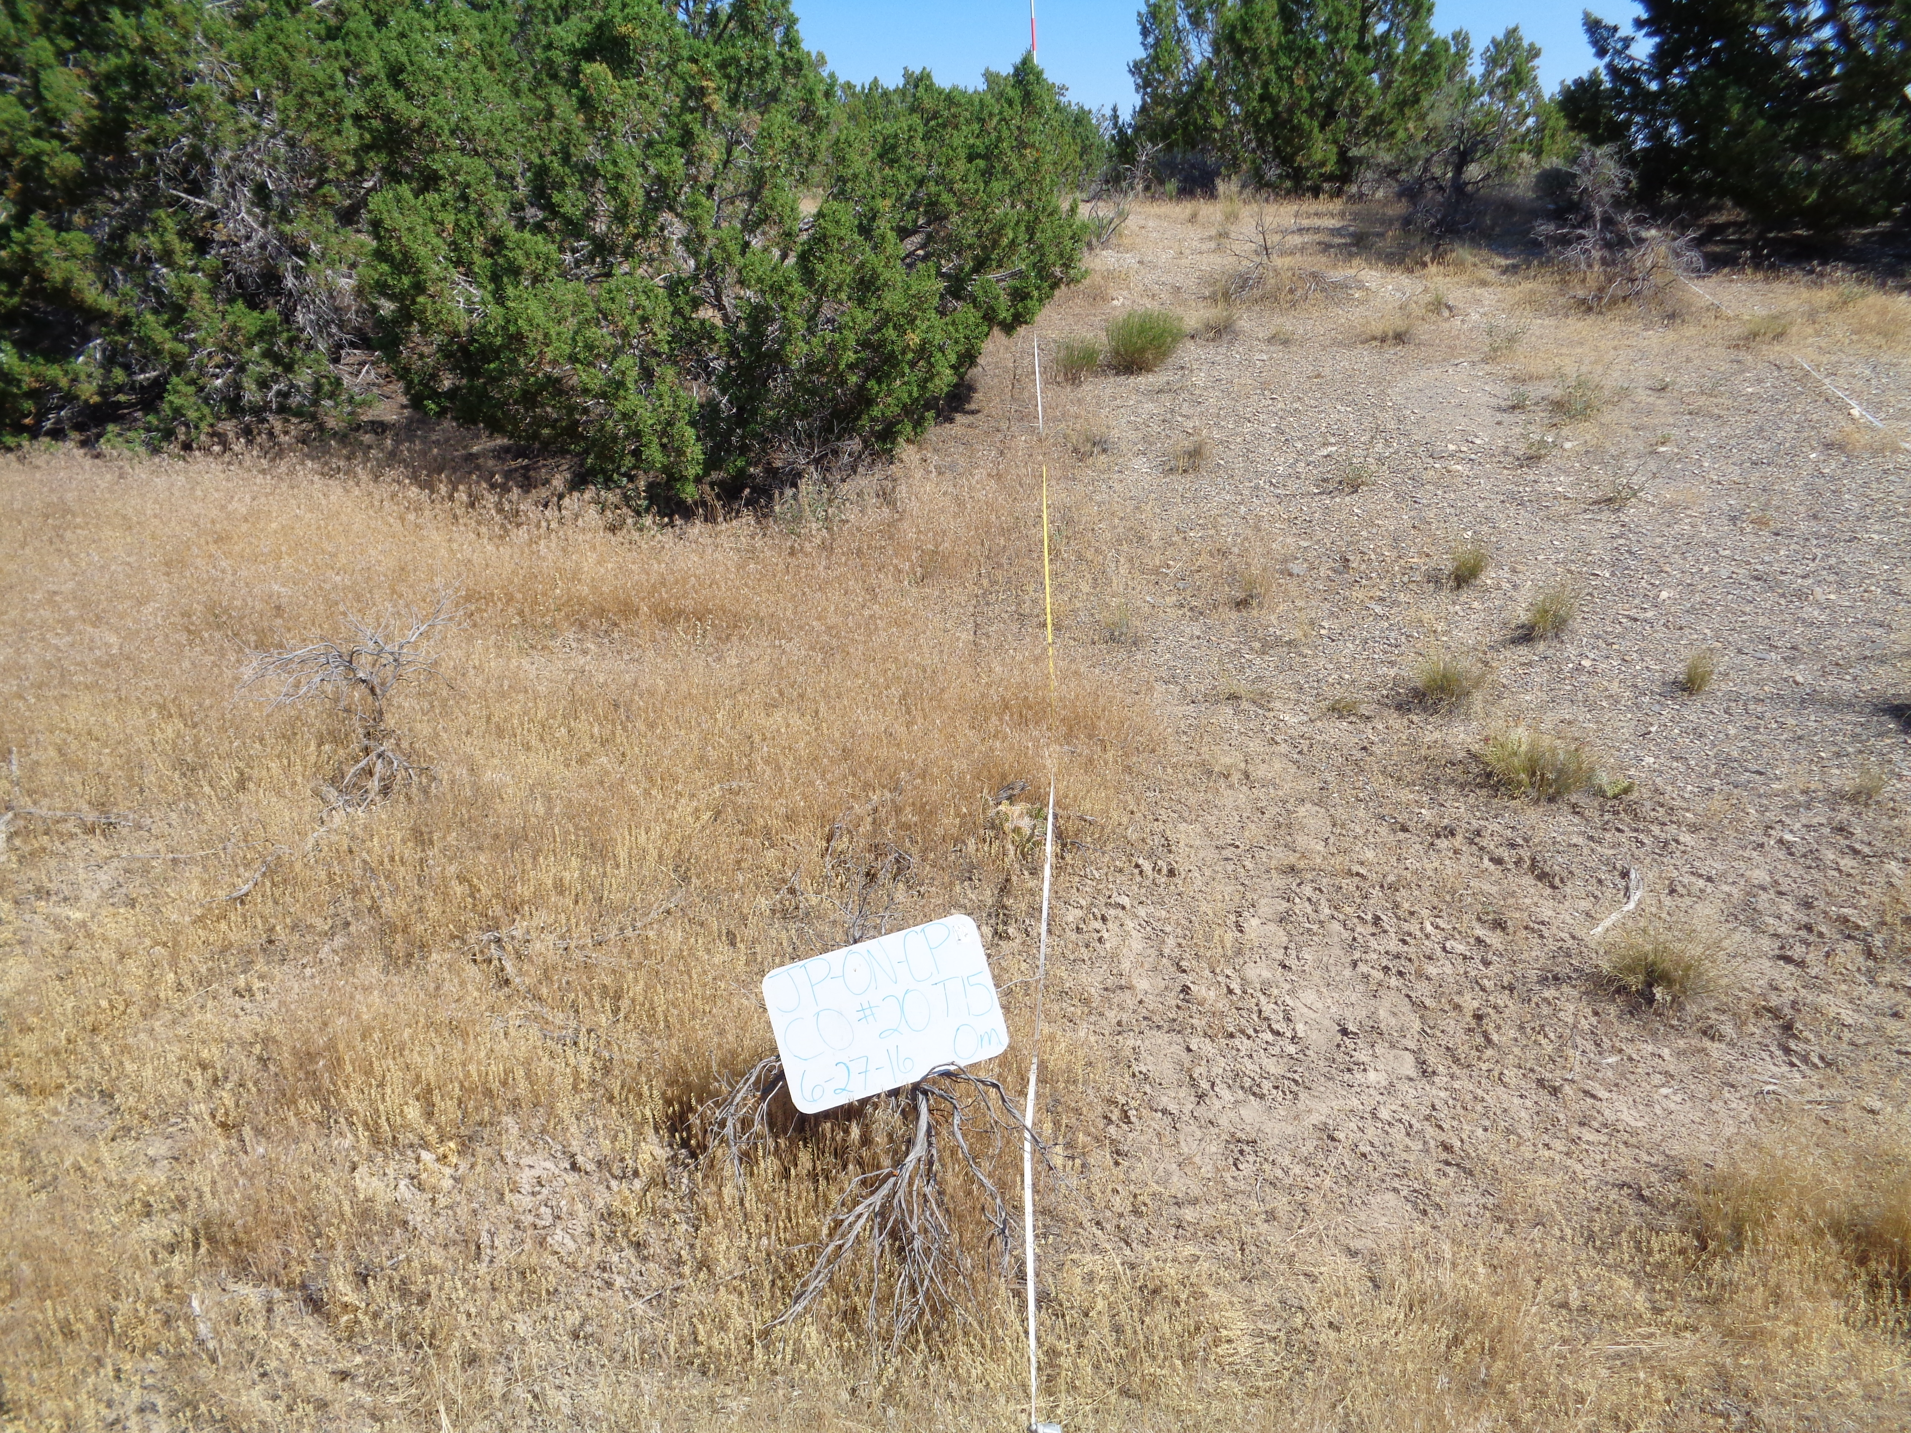

Site: Elevation: Treatment Date:

Trees: Shrub: Perennial Grass: Total Grass: Bare Ground:

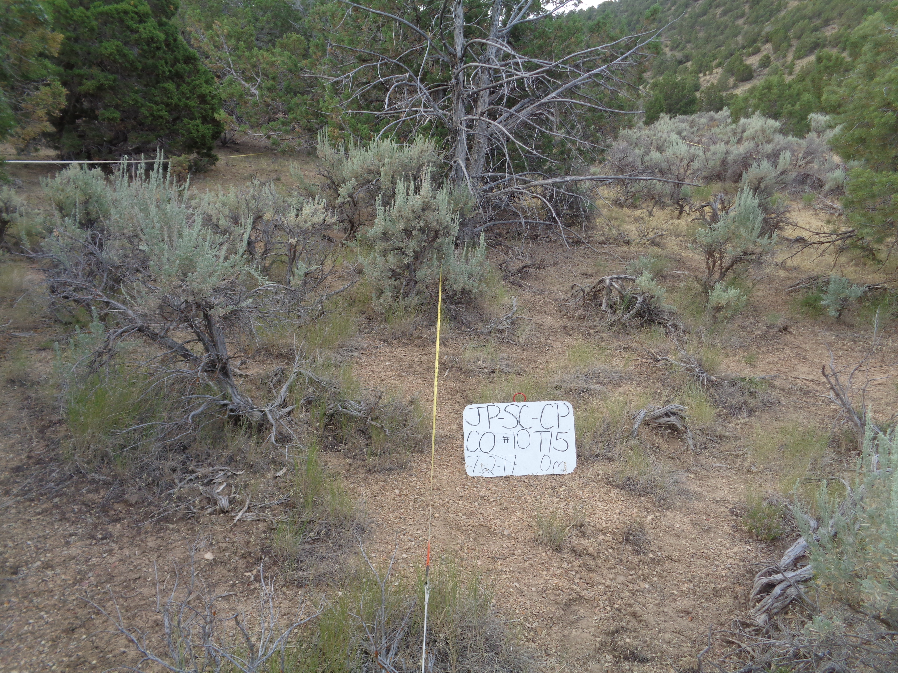

|  |  |  |  |  |  |
| --- | --- | --- | --- | --- | --- |
| Control Phase 2 | | | | | |
| Variable | Category | Component | Min | Mean | Max |
| **Total Cover (%)** | Trees | JUOS | 7 | 18 | 34 |
| PIED | 0 | 5 | 22 |
| Shrubs | ARTRW8 | 1 | 8 | 21 |
| CHVI8 | 0 | 1 | 6 |
| PUST | 0 | 0 | 0 |
| Herbaceous | Perennial Grass | 3 | 14 | 24 |
| Annual Grass | 0 | 5 | 33 |
| Forb | 1 | 20 | 39 |
| Litter & Duff | Interspace Litter | 31 | 49 | 64 |
| Bare Ground | Bare Ground | 56 | 72 | 85 |
| **Density (#/acre)** | Trees | JUOS | 37 | 126 | 311 |
| PIED | 0 | 60 | 276 |
| Shrubs | ARTRW8 | 318 | 1373 | 2453 |
| CHVI8 | 0 | 670 | 3883 |
| PUST | 0 | 0 | 0 |
| **Height (in)** | Shrubs | ARTW8 | 8 | 20 | 36 |
| CHVI8 | 0 | 4 | 12 |
| PUST | 0 | 0 | 0 |
| Herbaceous | Grass | 2 | 7 | 12 |
| Forb | 1 | 3 | 6 |
| **Fuel Loading (tons/acre)** | Shrubs | ARTRW8 | 0.000 | 0.725 | 2.839 |
| CHVI8 | 0.000 | 0.004 | 0.047 |
| PUST | 0.000 | 0.000 | 0.000 |
| Herbaceous | Live | 0.013 | 0.068 | 0.178 |
| Dead | 0.000 | 0.023 | 0.249 |
| Downed Woody Debris | 10-hr | 0.099 | 0.309 | 0.699 |
| 100-hr | 0.099 | 0.560 | 1.279 |
| 1000-hr sound | 0.000 | 0.160 | 0.567 |
| 1000-hr rotten | 0.000 | 0.058 | 0.257 |
| Litter & Duff | Interspace Litter | 0.000 | 0.240 | 0.871 |
| Tree Litter + Duff | 3.439 | 7.900 | 19.305 |
| **Bulk Density (lbs/ft3)** | Shrubs | ARTRW8 | 0.0000 | 0.0143 | 0.0401 |
| CHVI8 | 0.0000 | 0.0001 | 0.0017 |
| PUST | 0.0000 | 0.0000 | 0.0000 |
| Herbaceous | Total (live + dead) |  |  |  |